General Body Meeting

IEEE MVSR SB Circuits and Systems Society (CASS) conducted its first General Body Meeting (GBM), on 20th July 2023. The objective of this meeting was to plan about the future events to be organized, monitor the functioning of the society and establish an appropriate timeline for all upcoming events.

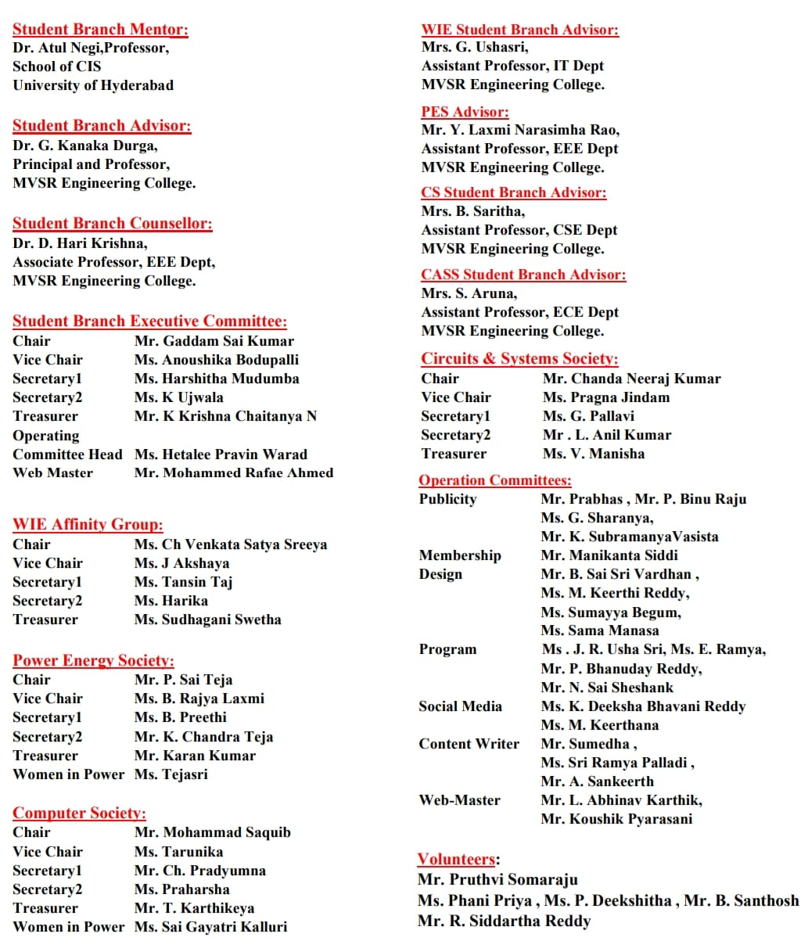

Session Details:

Date: 20th July, 2023

Timings: 3 PM - 4 PM

No. of Attendees: 8

The meeting was initiated by Mr. Chanda Neeraj Kumar, Chairperson, IEEE MVSR SB CASS, by welcoming all the members present in the meet. Then, Mrs. S. Aruna, Student Chapter Advisor, IEEE MVSR SB CASS, firstly congratulated the newly formed ExCom and presented various ideas regarding events that could be organized by the society and first event discussed was to conduct an E-waste management program in the month of September. She also discussed about a 6-day Value Added Course on Cadence, industrial visit, IOT skill connect program, professional development program and an awareness program on career paths for school students. Apart from this, she asked all the executive members to put forward their ideas about the events.

Firstly, Mr. Chanda Neeraj Kumar, Chairperson, IEEE MVSR SB CASS, came up with ideas such as, a value-added course on VLSI and a workshop on IOT using Arduino. Then, Mr. G. Sai Kumar, Chairperson, IEEE MVSR SB advised to conduct an awareness program on IEEE to the freshers.

Subsequently, Ms. B. Anoushika, Vice-Chairperson, IEEE MVSR SB, suggested to conduct social events like orphanage drive. Later, Ms. G. Pallavi, Secretary, IEEE MVSR SB CASS, suggested about a seminar on project selection for career success.

Dr. D. Harikrishna, the Student Branch Counsellor of IEEE MVSR SB, addressed the gathering. A minimum of six events were suggested for the committee to organize, encompassing a well-balanced mix of technical and non-technical activities, workshops, and industrial visits. Dr. Harikrishna emphasized the value of designating a dedicated team member to explore potential awards available to CASS. Another essential aspect highlighted was the need to conduct a membership drive to educate students about the benefits of joining the society, fostering a sense of community and enabling professional growth. Overall, his recommendations provided invaluable insights for the committee in planning a successful and rewarding calendar of events for the year ahead.

Group picture of members present in the Meet

Finally, the meeting was ended by Ms. J. Pragna, Vice-Chairperson, IEEE MVSR SB CASS, by proposing the vote of thanks.

Reported by:
IEEE MVSR SB

